**USE CASE DIAGRAM**

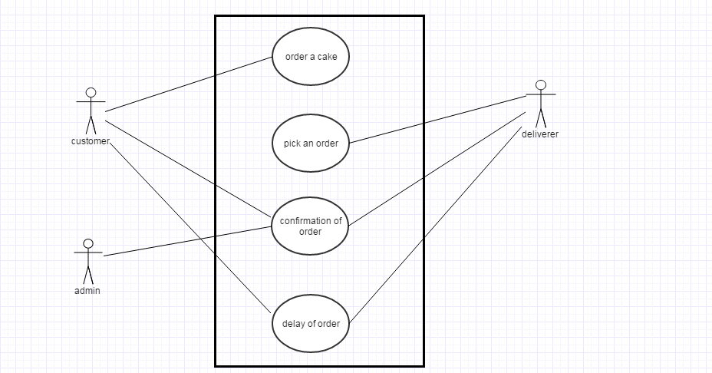

**ERROR CASE**

The last usecase i.e Delay in Order in the above Usecase diagram is Error case in which the Deliverer delays the order.

Here when the customer orders a cake. It is updated in database then Deliverer selects that order for the delivery.

Admins gets the confirmation from the Deliverer that he would deliver so admin sends the confirmation and estimated delivery time to the customer.But the deliverer does'nt deliver on time due to some reasons.